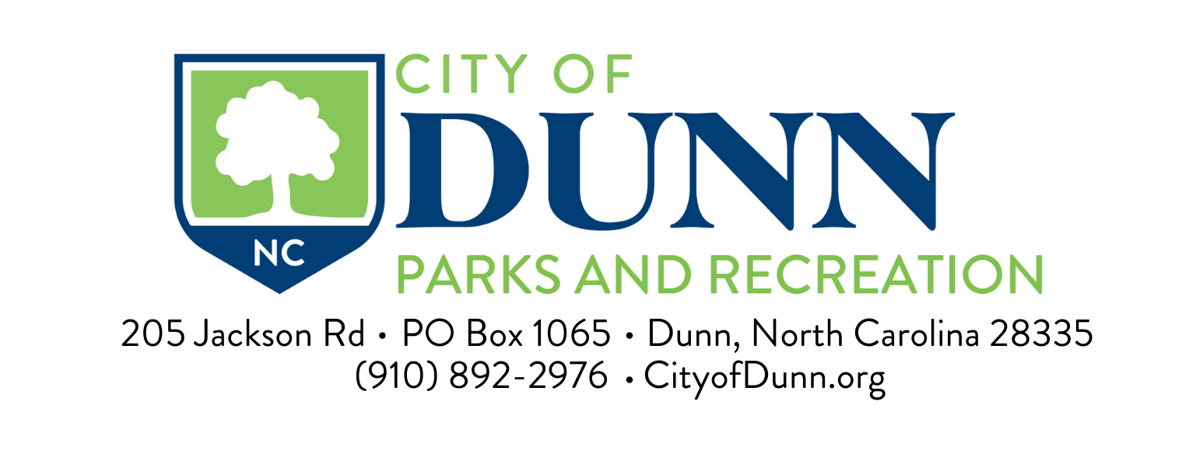
Thank you for your interest in leasing the Dunn Community Center. This packet contains the Dunn Community Center Lease Terms and Conditions of Hire, an Exit Checklist, Dunn Community Center Lease Application, and the Dunn Community Center Lease Agreement. Please review all of the information carefully before you complete the Dunn Community Center Lease Agreement forms.
Here are a few important things to keep in mind:
- You must complete the Dunn Community Center Lease Application (page 7), the Dunn Community Center Lease Agreement (pages 8 & 9), and provide a deposit check in the amount of $300 for us to hold the date you would like to lease the Dunn Community Center Building. Your deposit fee will be mailed back to you after your event if there is no damage to the building.

- The rent payment is due five (5) business days prior to the date of the event. Any rentals not paid within 5 business days, we the lessor reserve the right to cancel the scheduled event.

- We do not give Dunn Community Center keys out to anyone. The building will be unlocked and locked at the times you specify on the Dunn Community Center Application. Be certain that you have designated someone to remain at the building at all times once it has been unlocked.

- You will need to make a copy for your records of pages 7, 8, & 9 (the Dunn Community Center Lease Application Form and the Lease Agreement Forms)

The Dunn Community Center

Lease Terms & Conditions of Hire

- All applications for use of the Dunn Community Center must be made on the Dunn Community Center Application Form (page 7). The Dunn Community Center Application Form, the Dunn Community Center Building Lease Agreement Forms (pages 8 & 9)
- You may return this information in person to the Dunn Parks & Recreation Department at 205 Jackson Road (inside the Community Center). The Lessor reserves the right to refuse any application without stating their reason for doing so.
- If the lessor accepts the application the Organization and the Contact Person whose name appears on the Dunn Community Center Lease Agreement Form shall be deemed to be the lessee and shall be jointly and severally liable and responsible for all charges and payments and for compliance with these regulations and conditions. Additionally, the deposit will be kept to cover all loss or damages.
- A deposit in the amount of $300 must accompany the application and lease agreement to secure your date. If the application is accepted the rental fee of $500 must be received at least five (5) business days prior to the event.
- Checks must be made payable to the City of Dunn Parks and Recreation.
- If the Lessee cancels the event, the deposit will not be refunded, unless the event is canceled at least five (5) business days prior to the event date. The city will use the postmark date.
- Litter must not be left in or around the premises or the lessor will keep a portion of the deposit to cover the cost of clean-up.
- The city shall not discriminate against users based on race, gender, color, creed, religion, national origin or political affiliation, nor shall it lease to those who do.
- The Community Center shall not be used for any unlawful or offensive purposes and all users must abide by local, state and federal laws.
- No alcoholic beverages/smoking allowed on premises.
- No loud music allowed.
- No flammable decorations are to be installed without first securing the approval of the director. The use of tape or the driving of nails, tacks, or other metal articles into the walls or otherwise defacing the property is prohibited.
- The City will set up the center based on the attached layout (page 4). Any changes to the layout will be the responsibility of the lessee.

- Any city-owned equipment or other property destroyed, stolen or abused while the Dunn Community Center Building is leased to a user shall be replaced and/or repaired by the user.
- Any privately-owned equipment brought in, set up and then taken out by the user at the conclusion of the lease period and shall not be left over or stored on the premises.
- Appliances used must be cleaned prior to the signing exit checklist.
- Use of the Dunn Community Center is restricted to the lessee and their invited guests. The Lessee shall not sublease or assign use of the premises.

Lease Terms & Conditions of Hire Continued

- Hours of operation are weekdays and Sunday from 8 a.m. until 10 p.m. and weekends from 8 a.m. until 11 p.m.
- Someone will come and unlock the center and lock it back at the times that you specify. Someone will need to remain in the center at all times while it is unlocked. No key will be given for any reason. The center will be locked if found unattended by staff.
- Someone from the maintenance staff will give you an exit checklist upon arrival the day of your event.

The Dunn Community Center has 8’ tables (25), folding chairs (200) – 165 parking spaces –
8’ x 32’ stage – tabletop or floor podium – sound system with cd player – projector screen --four microphones with stands – full catering kitchen with stove, refrigerator, upright freezer and commercial ice machine.

Please contact Maintenance Supervisor Chris Monk Cell: 919-820-3457 for any emergencies and early closures of the center.

Basic Setup

Exit Check List

Make sure you don’t secure anything to the walls unless you are using the strip attachment on the wall.

Do not hang anything in the windows that may cause damage when removing items.

Do not allow kids to play with the projector screen/controls.

Any damages to the stage from misuse such as dragging equipment or tables across the surface area.

Make sure stovetop and burner pans are clean. Use oven cleaner that is under the sink. (DO NOT USE STEEL WOOL OR ANY OTHER TYPE SCRUBER THAT MAY SCRATCH THE STOVE TOP)

Wipe out any spills in oven

Wipe off all counter tops.

Clean out sinks.

Clean off any spills from cabinet doors.

Sweep kitchen floor and mop any spills.

Empty all trash cans.

Clean out bathrooms – wipe off toilet seats, clean out sinks, and wipe off counter top.

Sweep dining room floor and bathrooms. Mop up any spills.

CLEANING ITEMS ARE LOCATED IN THE CABINET UNDER THE SINK

*** FORFEITURE OF YOUR DEPOSIT WILL OCCUR IF THESE THINGS

ARE NOT DONE ***

Dunn Community Center
Post Office Box 1065

Dunn, NC 28335
(910) 892-2976 Fax (910) 892-7001

(Application For Use)

Date of Application: ___________________________________________
Date of Event: ________________________________________________
Name of Event _______________________________________________
Contact Person _______________________________________________
Address (Street and PO Box) ____________________________________
City: ________________________State ____________Zip ____________
Day Phone __________________Evening Phone ____________________
Fax ________________________Email ____________________________

Description of Function
______________________________________________________________________________

Access Time:___________________ (Time We Will Unlock The Facility)
Clear Time: _____________________(Time We Will Lock The Facility)
(someone will unlock and lock the center – no key will be given for any reason)

Fill in with number( where quantity is needed); (yes) (no) and circle choice

Seating for ________ (quantity of tables and chairs only) (quantity if chairs only)

Serving Line ______ (quantity of tables) Head Table ______ (on stage) (on floor)

Podium (tabletop/floor) ______ Microphones ______ (1) (2) (3) (4)

Thank you for completing this form. Please return this application along with the deposit and retain the Dunn Community Center Lease Terms and Conditions of Hire for your reference. We recommend that you retain a photocopy of this form for your own records, as this is the form we will use when setting up and opening and closing center. A Dunn Community Center Lease Agreement, binding the contract between your organization and the City of Dunn must be completed if this application is approved.

I have read the Dunn Community Center Lease Terms and Conditions of hire and confirm that the organization on whose behalf I am applying accepts with reservation.

Signature: ________________________________________

Organization: ______________________________________

Office Use Only
AMOUNT | CASH | CK # | RENT | DEPOSIT | RECEIPT NO.

Event Setup

- Use this page to indicate how you would like for tables, chairs and microphones to be arranged prior to your arrival.
- Staff will use the basic setup format (page 3) if you do not complete this page.
- You are free to change table and chair arrangements once you arrive.
- Please provide setup five (5) business days prior to your event

DUNN COMMUNITY CENTER

LEASE AGREEMENT

RENT & DEPOSIT
Lessee promises to pay Lessor the rental sum of Five Hundred Dollars ($500) which sum is to be paid upon Lessee’s execution of this agreement or at least five (5) days prior to the event. This amount will cover the cost of the facility for one day.

Lessee shall further deposit with the Lessor the sum of Three Hundred Dollars ($300) from which Lessor may deduct the cost of any damage, repair, or cleaning required as a result of the Lessee’s failure to return the premises in the conditions required by this Agreement. The balance of the deposit shall be returned to the Lessee.

OTHER TERMS & CONDITIONS
Lessee will pay the costs, as determined by the Lessor, of repairing any damage, which may be done to the premises or any fixtures, furniture or furnishings thereof by an act of Lessee or anyone visiting the Premises. If the premises are not cleaned properly as determined by Lessor, the Lessee’s deposit shall be applied to the total cost of cleaning the center as well as for the cost to repair any other damages as provided for in this Agreement. The Lessee’s liability shall not be limited to the amount of cash deposit. Any necessary expenses exceeding the deposit shall be borne by the Lessee and shall be due and payable within 30 days of the receipt of any invoice from the Lessor.

Dunn Community Center
Lease Agreement Continued

The Lessee stipulates that he/she/they/them has examined the premises prior to the execution of this Agreement and is satisfied with the physical condition of said premises, and Lessee’s taking possession thereof shall be conclusive evidence of its receipt of said premises in a safe, sanitary and fair condition and in good repair.

The Lessee shall assume all risks instant to or in connection with the activity to be conducted hereunder and shall be solely responsible for all accidents or injuries whatsoever of any nature or kind to persons or property caused by its use of these premises. The Lessee further agrees to indemnify the Lessor and save it harmless from any and all claims or liability for personal injuries or other damages to any person, including injuries resulting in the death of any person which injury or death is occasioned by or in connection with the use of the premises herein rented. The Lessee further assumes full responsibility for the character, acts and conduct of all persons admitted to said premises by the consent of the Lessee.

In renting the premises, Lessor does not relinquish the right to control the management thereof, and to enforce all necessary and property rules for management and operation of the same, and Lessor, through its director, policemen, firemen and other designated representatives, shall have the right at any time to enter any portion of said premises for any purpose whatsoever.

Lessee agrees to abide by all Terms and Conditions of the Dunn Community Center, which are incorporated herein by reference and made a part of this Agreement.

In witness whereof, the parties have agreed upon the above written:

Lessor Lessee

________________________ Signature: ____________________________
City of Dunn, NC
Print Name: ____________________________

Date: ________________________ Mailing Address: _________________________
__________________________

Phone: (____) _____- ________

Date: _____________________

Mission Statement

The City of Dunn Parks and Recreation Department is dedicated to creating positive experiences by providing quality parks, facilities, services and programs for all our citizens. The goal of our youth athletic program is to offer a rich year-round schedule of athletic activities that encourage children to play a variety of sports, and to provide them with the opportunity to have fun while developing physically, emotionally and socially. The Recreation Department will strive to teach skills and sportsmanship through participation in the development of all youth and to teach the rules of play in each specific sport.

