DUNN PARKS & RECREATION 910-892-2976



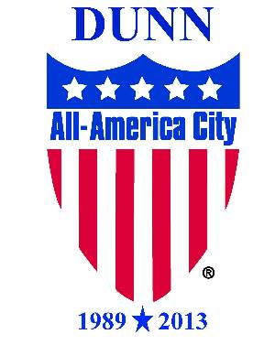

**2021 TBALL PRACTICE SCHEDULE**

**Team Name Coach**

**Team 1**  Signs & Awning Systems Jamie McLamb

**Team 2** Top Armor Contracting Joshua Terranova

**Team 3** NKS Contracting Matt Willis

**Team 4** Lee’s Insurance Paul Bates

* **All practices will be held on the FOOTBALL FIELD at Tart Park.**

**-This field is beside the Dr. P.K. Vyas, MD Recreation Center.**

**-ALL T-BALL GAMES WILL BE ON FIELD #1 (CLOSEST TO THE VYAS CENTER)**

* **Once games start you may continue to practice on Saturdays only if you’d like.**

|  |  |  |  |  |  |
| --- | --- | --- | --- | --- | --- |
| **MONDAY**  **APRIL 26, 2021** | | **TUESDAY**  **APRIL 27, 2021** | | **SATURDAY**  **MAY 1, 2021** | |
| 6:00pm | Team 1 | 6:00pm | Team 3 | 9:00am | Team 4 |
| 6:45pm | Team 4 | 6:45pm | Team 2 | 9:45am | Team 3 |
|  |  |  |  | 10:30am | Team 2 |
|  |  |  |  | 11:15am | Team 1 |
|  |  |  |  |  |  |
| **MONDAY**  **MAY 3, 2021** | | **TUESDAY**  **MAY 4, 2021** | |
| 6:00pm | Team 1 | 6:00pm | Team 3 |
| 6:45pm | Team 4 | 6:45pm | Team 2 |