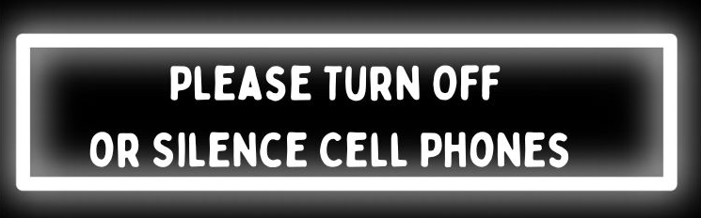
City Council
Work session
6:30pm, Tuesday, August 12, 2025

Dunn Municipal Building
401 East Broad Street
Dunn, North Carolina 28334

-Agenda-

1. Call to Order – William P. Elmore, Jr., Mayor

2. Invocation

3. Pledge of Allegiance – April Gaulden, Mayor Pro Tem

4. Consideration & Approval of the Agenda

5. Consent Agenda
Consent Agenda items are considered and approved by a single motion and vote. Any member of the City Council may request an item be removed, without a motion or a vote, from the Consent Agenda for separate consideration. If an item is removed from the Consent Agenda, that item will be placed under the Items for Discussion & Possible Action section of the agenda.

A. July 22, 2025 Regular Meeting Minutes
B. July 28, 2025 Special Called Meeting Minutes
C. Special Event Permit – Dunn Elementary School Festival
D. Special Event Permit – Chalk Fest

6. Items for Discussion & Possible Action

- Future Use of Council Chambers for District Court
- USDA Loan – Vehicle/Equipment
  - Public Hearing
  - Decision
- Funding of Police and Inspection Vehicles
D. FY26 Fee Schedule Revisions
E. Capital Project Ordinance Amendment and Budget Amendment for CDBG-1 Sewer Collection System Project
F. Personnel Policy Amendment – Exempt Employees Working During States of Emergency

7. Announcements

8. Closed Session
If called, the motion to enter closed session must cite the North Carolina General Statute that authorizes the closed session.

9. Adjournment

The City of Dunn is an equal opportunity provider and employer.

